Virtual Pet Simulator (Kisa.net ฅᨐฅ)
Team Members: Kubeyeva Aliya, Zhaulbay Malika, Moldash Aknaz
CSS 217
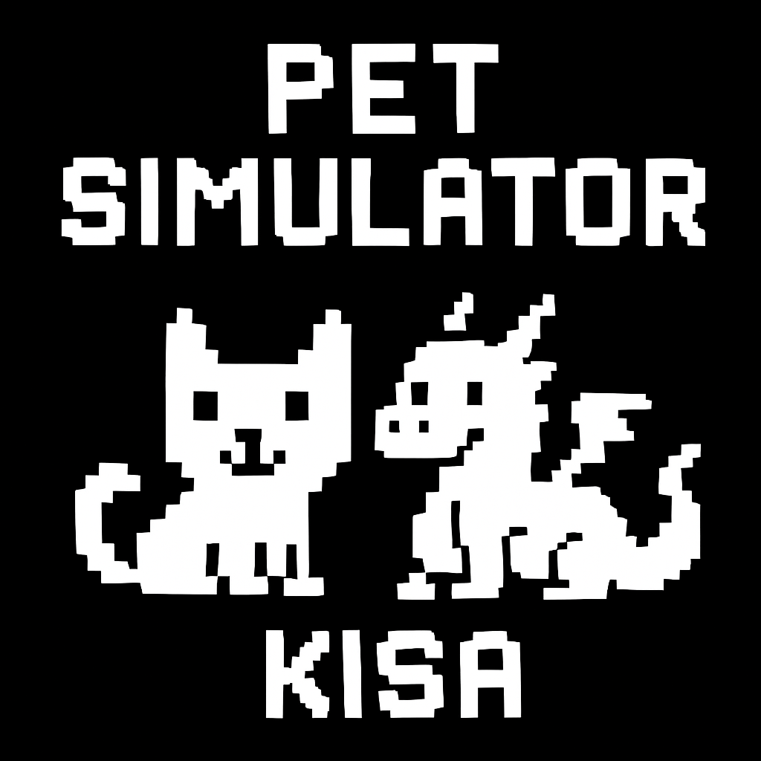

1. App Overview ᓚ₍⑅^..^₎♡

1.1 Project Description
Virtual Pet Simulator is a fully functional console-based game that allows players to create, manage, and interact with virtual pets (Cats and Dragons). The project uses Design Patterns, and follows SOLID principles.

1.2 What can the game do?
- Pet Creation & Management: Create pets with unique names and characteristics
- Dynamic State System: Pets act differently based on their current state (Happy, Normal, Hungry, Sleeping, Dead)
- Progression System: Enhance pets with equipment (Armor, Amulets) that provide permanent bonuses
- Storage: All pet data is stored in SQLite database
- Statistics Tracking: Comprehensive tracking of pet activities and game history
- Multiple Save Slots: Support for multiple pets with independent save files

1.3 Technologies:
- Language: Java
- Database: SQLite

1.4 Gameplay Loop
- User creates or loads a pet from the database
- Pet starts with initial stats of Health, Energy, Hunger, Happiness
- User performs actions: Feed, Play, Sleep, Buy items
- Pet's state changes automatically based on stats
- Game saves progress to database after each action
- A pet can die if its health reaches zero !!!

2. How Design Patterns were used?
The application implements three design patterns :

2.1 Builder Pattern (Creational)
Builder is a creational design pattern that lets you construct complex objects step by step. The pattern allows you to produce different types and representations of an object using the same construction code.
Where used?: PetBuilder class
Purpose: Constructs complex Pet objects step-by-step, providing clear, readable code..
Benefits:
- Readability: Clear what each parameter represents
- Flexibility: Can set only needed parameters (others use defaults)
- Validation: Can add validation logic before building
Why This Pattern?
- Pets have 5+ initialization parameters(it would’ve been messy with constructor )
- Different pet types (Cat, Dragon) have different default values
- Provides a fluent, readable API for pet creation
- Allows easy extension for new pet types without changing client code

2.2 State Pattern (Behavioral)
State is a behavioral design pattern that lets an object alter its behavior when its internal state changes. It appears as if the object changed its class.
Where used? : IPetState interface and implementations
Purpose: Allows pet objects to alter their behavior when their internal state changes. The pet appears to change its class.
Problem: Without State pattern, all the behavioral differences would’ve been written as many if else statements.
Benefits:
- Open/Closed Principle: Add new states without modifying existing code
- Single Responsibility: Each state class handles one behavior
- Maintainability: State logic is isolated and easy to test
- Readability: Clear what happens in each state
- Polymorphism: Runtime behavior changes based on state object
Why This Pattern?
Pet behavior varies based on condition
- Eliminates complex if-else chains (violates OCP)
- Makes adding new states easy (just create new class)
- State transitions happen naturally based on stats

2.3 Decorator Pattern (Structural)
Decorator is a structural design pattern that lets you attach new behaviors to objects by placing these objects inside special wrapper objects that contain the behaviors.
Where used? : PetDecorator and concrete decorators
Purpose: Dynamically adds responsibilities to objects without modifying their structure. Provides a flexible alternative to subclassing for extending functionality.
Problem Solved: Without Decorator, we'd need inheritance problem:
class Cat { }
class ArmoredCat extends Cat { }
class MagicCat extends Cat { }
class ArmoredMagicCat extends ArmoredCat { }
class MagicArmoredCat extends MagicCat { }
Benefits:
- Flexibility: Add/remove enhancements at runtime
- Composition over Inheritance: Avoid class explosion
- Single Responsibility: Each decorator has one enhancement
- Open/Closed: Add new decorators without changing pet classes
- Stackable: Combine multiple decorators freely

Why This Pattern?
Equipment can be added/removed dynamically during gameplay
- Avoids creating separate classes for every equipment combination
- Allows stacking multiple enhancements (armor + amulet + future items)
- Equipment effects persist across database save/load
- Easy to add new equipment types without touching existing code

2.4 Database
DatabaseManager class
- Database logic isolated in one class (SRP)
- Easy to swap database implementations (MySQL, PostgreSQL)
- Centralized data access
- Business logic (GameEngine) doesn't know about SQL

3. SOLID Principles Application
Our architecture strictly follows all five SOLID principles:

3.1 Single Responsibility Principle (SRP)
A class should have only one reason to change.

Class | Single Responsibility
Pet | Stores pet attributes and state reference
HappyState | Handles behavior when pet is happy
PetBuilder | Constructs pet objects
ArmorDecorator | Adds armor enhancement
DatabaseManager | Manages all database operations
GameEngine | Controls game loop and user interaction

Benefits in Our Project:
- Easy to find problems (each class has clear purpose)
- Simple testing
- Team members can work on different classes independently

3.2 Open/Closed Principle (OCP)
Software entities should be open for extension but closed for modification.
Implementation Example 1: State Pattern
Adding a new state requires ZERO changes to existing code:
NEW state - no modifications to Pet, GameEngine, or other states
class ExhaustedState implements IPetState {

public void handleFeed(IPet pet) {
System.out.println("Too exhausted to eat...");
}
public void handlePlay(IPet pet) {
System.out.println("Cannot play, need rest!");
}
public String getStateName() { return "( ꩜ ᯅ ꩜;)⁭ ⁭Exhausted"; }
}
Implementation Example 2: Decorator Pattern
Adding new equipment requires no changes to existing decorators:
class MagicSwordDecorator extends PetDecorator {

public void feed() {
wrappedPet.feed();
// Sword gives bonus happiness when eating
setHappiness(getHappiness() + 5);
}

public String getType() {
return wrappedPet.getType() + " ⚔️ [Sword]";
}
}
Can combine with existing decorators
Benefits:
- Add features without risking existing functionality
- Reduces regression bugs
- Safer for large codebases with multiple developers

3.3 Liskov Substitution Principle (LSP)
Objects of a superclass should be replaceable with objects of its subclasses without breaking the application.
1)Pet Hierarchy
Both Cat and Dragon can substitute Pet
2)State Substitution
All states are interchangeable through IPetState interface
3)Decorator Substitution
Decorators are fully substitutable for IPet
Benefits:
- Code is polymorphic and flexible
- Can add new pet types without changing GameEngine
- Testing is easier (mock any subtype)

3.4 Interface Segregation Principle (ISP)
No client should be forced to depend on methods it does not use.
1)Focused Interfaces
Small, focused interface for pets
interface IPet {
String getName();
int getHealth();
void feed();
void play();
void sleep();
ONLY essential pet operations
}

Small, focused interface for states
interface IPetState {
void handleFeed(IPet pet);
void handlePlay(IPet pet);
void handleSleep(IPet pet);
void handleTick(IPet pet);
String getStateName();
ONLY state behavior methods
}
What we did?
- IPet: Only pet-specific operations
- IPetState: Only state behavior
- DatabaseManager: Separate class for persistence
- GameEngine: Separate class for UI/interaction

3.5 Dependency Inversion Principle (DIP)
High-level modules should not depend on low-level modules. Both should depend on abstractions.
1.GameEngine → IPet
High-level module (GameEngine) depends on abstraction (IPet)
Low-level modules (Cat, Dragon) implement the abstraction
2.Pet → IPetState
Pet (high-level) depends on IPetState (abstraction)
States (low-level) implement the abstraction
Benefits:
- GameEngine doesn't care about concrete pet types
- Easy to add new pets without changing GameEngine
- Components are loosely coupled
- Easier testing with mock implementations

4. User Guide

4.1 Gameplay Guide

Main Menu
When you start the game, you'll see:
============================================================
₍^. .^₎⟆ WELCOME TO VIRTUAL PET SIMULATOR
============================================================

🏠 MAIN MENU:
1. 🆕 Create New Pet
2. 📂 Load Saved Pet
3. 📋 View All Saved Pets
4. 🗑️ Delete Pet
5. 🚪 Exit
Choice:

Creating a New Pet
- Select option 1 from main menu
- Choose pet type:
- Cat: 🐱 Higher base energy (100), agile, faster movements
- Dragon: 🐉 Higher base health (150), powerful, stronger
- Enter pet name (or press Enter for default name "Buddy")
- Pet is automatically saved to database
Example:
🐾 Choose your pet:
1. 🐱 Cat (Higher energy, agile)
2. 🐉 Dragon (Higher health, powerful)
Choice: 1

📝 Enter pet name: Fluffy

✅ 🐱 Cat Fluffy has been created!
💾 Pet saved to database with ID: 1

Understanding Pet Stats
Your pet has 4 main statistics:

Stat | Range | Description
❤️ Health | 0-150 | Pet's life points. Dies at 0
⚡ Energy | 0-100 | Ability to play. Sleeps when low
🍖 Hunger | 0-100 | Need for food. Refuses play when high
😊 Happiness | 0-100 | Overall mood. Affects state

Pet States
Your pet's behavior changes based on its stats:
State | Icon | Trigger | Behavior
Happy | 😊 | Happiness ≥70, Hunger <50, Energy >50 | Eats well, plays enthusiastically
Normal | 😐 | Balanced stats | Standard behavior
Hungry | 😠 | Hunger ≥80 | Refuses to play or sleep
Sleeping | 😴 | Energy ≤20 (or manual) | Regenerates energy, can't act
Dead | 💀 | Health ≤0 | Game over, pet deleted

Available Actions
During gameplay, you can:
Actions:
1. 🍖 Feed - Reduces hunger, increases happiness
2. 🎾 Play - Increases happiness, reduces energy
3. 😴 Sleep - Regenerates energy and health
4. 🛡️ Equip Armor - +30 Max HP (permanent)
5. ✨ Equip Amulet - +15 Happiness per turn (permanent)
6. 📊 View Statistics - Shows total feeds, plays, sleeps
7. 📜 View History - Shows recent 10 actions
8. 💾 Save & Exit - Saves progress and quits
9. 🚪 Exit Without Saving - Discards current session

Equipment System
Armor Decorator (🛡️):
- Cost: Free (one-time use)
- Effect: Increases max health by 30
- Permanent once equipped
- Visual: Adds ⚔️ [Armored] to pet type
Amulet Decorator (✨):
- Cost: Free (one-time use)
- Effect: +15 happiness every turn
- Permanent once equipped
- Visual: Adds ✨ [Amulet] to pet type
Stacking:
🐱 Cat - Base pet
🐱 Cat ⚔️ [Armored] - With armor (+30 HP)
🐱 Cat ⚔️ [Armored] ✨ [Amulet] - Both equipped

Statistics Tracking
View your pet's lifetime statistics:
📊 Pet Statistics:
🍖 Total Feeds: 45
🎾 Total Plays: 32
😴 Total Sleeps: 12
🔄 Total Turns: 89

Action History
View recent actions:
📜 Recent Activity:
2024-12-07 14:23:45 - FEED (HP:120 E:75 H:30 Happiness:85)
2024-12-07 14:23:12 - PLAY (HP:120 E:90 H:40 Happiness:70)
2024-12-07 14:22:58 - EQUIPPED_ARMOR (HP:120 E:95 H:42 Happiness:68)

Loading Saved Pets
- Select option 2 from main menu
- Choose pet from list (shows ID, name, type, health, last played)
- Pet loads with all stats, state, and equipment restored
Example:
📂 SAVED PETS:
1. ID: 1 | Fluffy | Type: 🐱 Cat | HP: 120 | Last Played: 2024-12-07
2. ID: 2 | Smaug | Type: 🐉 Dragon | HP: 180 | Last Played: 2024-12-06

Enter pet number to load (0 to cancel): 1
📂 Loaded pet: Fluffy
✅ Pet loaded successfully!

4.2 Gameplay Tips
Tip 1: Balance is key
- Keep hunger below 70 to avoid Hungry state
- Keep energy above 30 to stay active
- Feed regularly to maintain health
- Play often to boost happiness
Tip 2: Strategic Equipment
- Equip Armor early for survival buffer
- Equip Amulet for passive happiness gain
- Both are permanent investments
Tip 3: State Management
- Sleep when energy drops below 40 (proactive)
- Don't wait until forced into Sleeping state
- Feed before hunger reaches 70
- Happy state provides best stat gains
Tip 4: Pet Type Selection
- Choose Cat if you prefer: Active gameplay, frequent interactions, agility
- Choose Dragon if you prefer: Survival focus, longer sessions, power

5. Technical Architecture

5.1 Class Diagram
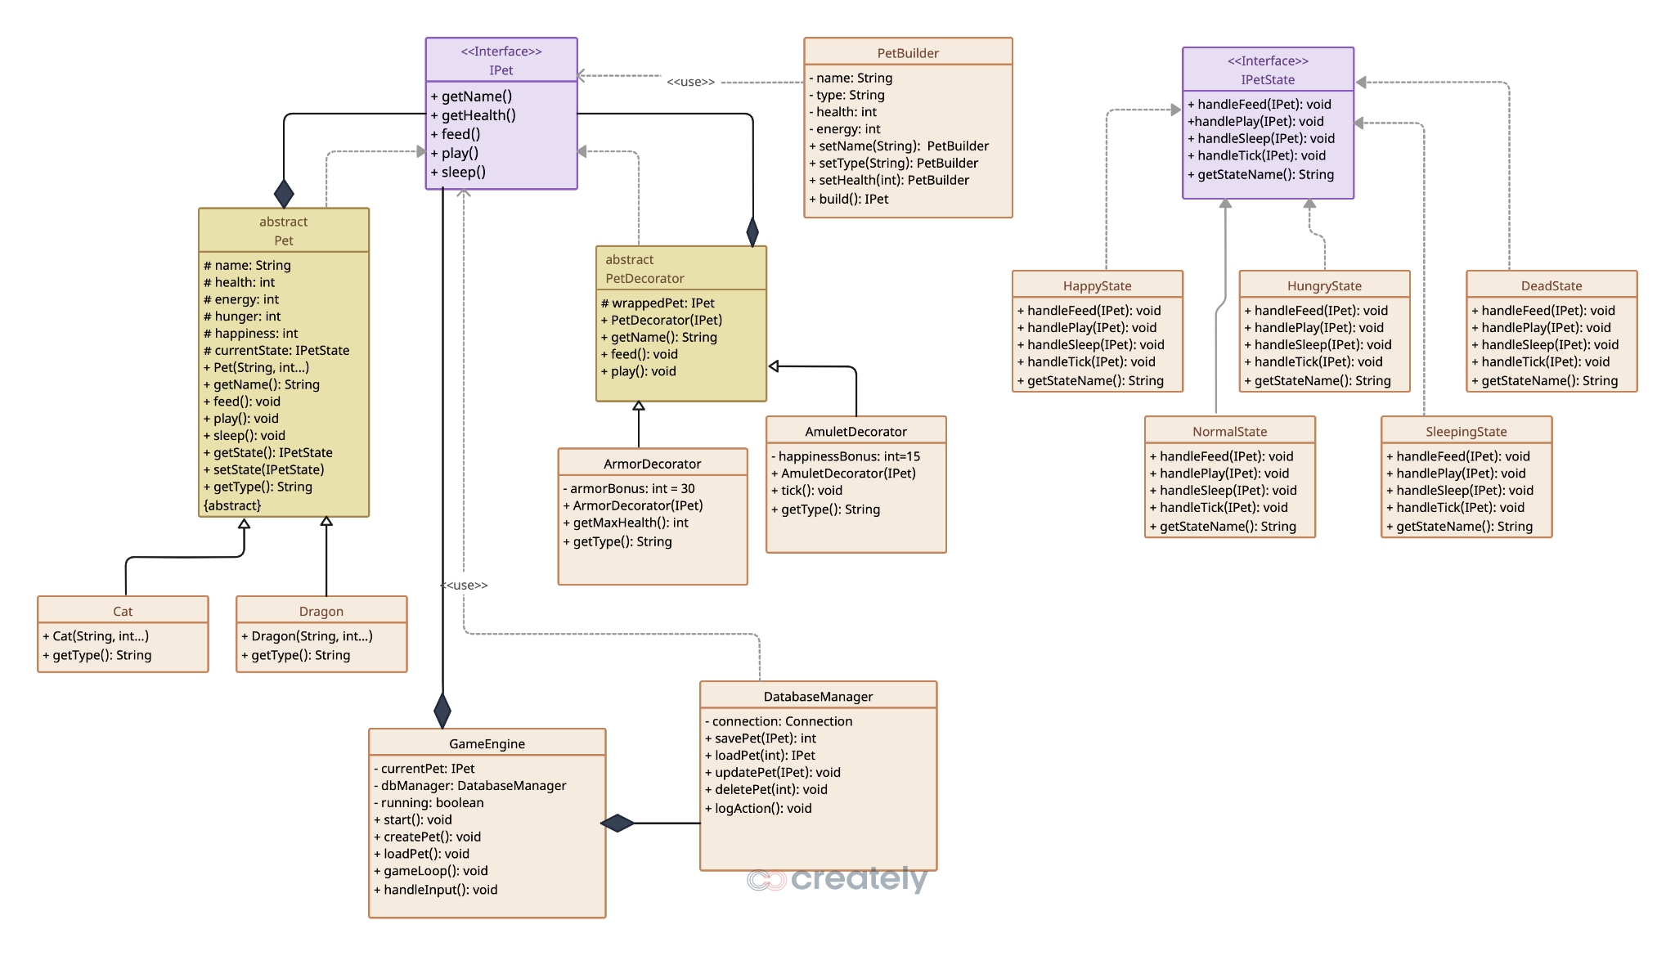

6. Conclusion
Virtual Pet Simulator successfully demonstrates:
- Three design patterns from different categories (Builder, State, Decorator)
- All five SOLID principles consistently applied throughout
- Fully functional application with real gameplay
- Database persistence with comprehensive CRUD operations
- Clean architecture with clear separation of concerns
- Extensible design allowing easy future enhancements

Has the potential of becoming indi-game.
